**Suicide Attempts Feed**

**“Education through self-help is our motto” – KARMAVEER**



**RAYAT SHIKSHAN SANSTHA’S**

**KARMAVEER BHAURAO PATIL COLLEGE**

**VASHI, NAVI MUMBAI -400703**

**[AUTONOMUS COLLEGE]**

**DEPARTMENT OF COMPUTER SCIENCE**

**CERTIFICATE**

This is certify that  **Pranali Kirolkar** students of T.Y. BSC (CS) from Karmaveer Bhaurao Patil College, Vashi Navi Mumbai has satisfactorily completed Final Year sem 6 project course in Computer Science as per the syllabus laid by Maharashtra State Board of technical education during the academic year 2018-2019.

Roll no: - **187519**.

Teacher In-charge Head

Date: / /2019 Dept of Computer Science



**RAYAT SHIKSHAN SANSTHA`S**

**KARMAVEER BHAURAO PATIL COLLEGE, VASHI**

**[Autonomous College]**

**2018-2019**

**A Project Report on**

**Suicide Attempts Feed**

**Exam Seat No: -187519**

**TY BSC COMPUTER SCIENCE**

**Guided By Developed By**

Miss. Nikisha Gawand-Dakee Kirolkar Pranali Piraji

**Acknowledgment**

I thank the almighty for giving us the courage and perseverance in completing the main project. This project itself is acknowledgments for all those people who have given us their heartfelt co-operation in making this project a grand success.

I extend our sincere thanks to Principal

Dr. **V.S.Shivankar** of our college, for providing sufficient infrastructure and a good environment in the College to complete our course.

With extreme jubilance and deepest gratitude, I would like to thank Head of the Computer Science Department **Ms. Manisha Abhyankar** for his constant encouragement. I am profoundly grateful towards the unmatched services rendered by him.

Our special thanks to my project guide

**Ms. Nikisha Gawand** and all the faculty of Computer Science department and peers for their valuable pieces of advice at every stage of this work.

Finally, we would like to express our deep sense of gratitude and earnest thanks for giving to our dear parents for their moral support and heartfelt cooperation in doing the project.

**INDEX**

|  |  |
| --- | --- |
| **SR**  **NO.** | **Name of Content** |
| 01 | Title page |
| 02 | Certificate |
| 03 | Acknowledgment |
| 04 | Plagiarism Report |
| 05 | Introduction |
| 06 | Requirements Specifications |
| 07 | System Design Details |
| 08 | System Implementation |
| 09 | Results |
| 10 | Conclusion |
| 11 | Future Enhancement |
| 12 | References |

**Introduction**

**Suicide** is the act of intentionally causing one's own [death](https://en.wikipedia.org/wiki/Death). Mental disorders, including [depression](https://en.wikipedia.org/wiki/Major_depressive_disorder), [bipolar disorder](https://en.wikipedia.org/wiki/Bipolar_disorder), [schizophrenia](https://en.wikipedia.org/wiki/Schizophrenia), [personality disorders](https://en.wikipedia.org/wiki/Personality_disorder), and [substance abuse](https://en.wikipedia.org/wiki/Substance_abuse)—including [alcoholism](https://en.wikipedia.org/wiki/Alcoholism) and the use of [benzodiazepines](https://en.wikipedia.org/wiki/Benzodiazepine)—are risk factor. Some suicides are [impulsive acts](https://en.wikipedia.org/wiki/Impulsivity) due to stress, such as from financial difficulties, troubles with [relationships](https://en.wikipedia.org/wiki/Interpersonal_relationship), or [bullying](https://en.wikipedia.org/wiki/Bullying).

Those who have previously attempted suicide are at a higher risk for future attempts Effective [suicide prevention](https://en.wikipedia.org/wiki/Suicide_prevention)efforts include limiting access to methods of suicide—such as [firearms](https://en.wikipedia.org/wiki/Firearms), drugs, and poisons; treating mental disorders and substance misuse; proper [media](https://en.wikipedia.org/wiki/Mass_media) reporting of suicide; and improving economic conditions. Even though [crisis hotlines](https://en.wikipedia.org/wiki/Crisis_hotline) are common, there is little evidence for their effectiveness.

The most commonly used [method of suicide](https://en.wikipedia.org/wiki/Suicide_methods) varies between countries, and is partly related to the availability of effective means.[]](https://en.wikipedia.org/wiki/Suicide#cite_note-Yip2012-12) Common methods of suicide include [hanging](https://en.wikipedia.org/wiki/Hanging), [pesticide poisoning](https://en.wikipedia.org/wiki/Pesticide_poisoning), and [firearms](https://en.wikipedia.org/wiki/Gun). Suicides resulted in 828,000 global deaths in 2015, an increase from 712,000 deaths in 1990. This makes suicide the 10th [leading cause of death](https://en.wikipedia.org/wiki/Leading_cause_of_death)worldwide.

In this project we discuss the total number of suicide attempts in various country and analyse it with the help of the Tableau software.

Show the graphical representation of the various graph.

**Requirements Specifications**

To give project is based on the following software and hardware for gives the stylish websites.

* Front end-
  + - * + HTML,CSS,JAVA SCRIPT
* Back end-
  + - MySql
* Modules:

Lattice

* OS-
  + window 10
* Software-

R-Studio

Tableau

Cloudera Virtual machine

**MODULE INFORMATION**

**Tableau software: -**

## Tableau is one of the most fast-growing data visualization tools which is currently being used in the BI industry. It is the best way to change or transform the raw set of data into an easily understandable format with zero technical skills and coding knowledge.

Tableau is greatly used because data can be analyzed very quickly with Tableau. Also, visualizations are generated as dashboards and worksheets. Tableau allows us to create dashboards that provide actionable insights and drives the business forward. The products of Tableau always operate in virtualized environments when they are configured with the proper underlying operating system and hardware. Tableau is used to explore data with limitless visual analytics.

**A few features of Tableau are given below:**

* Real-time analysis
* Data Blending
* Collaboration of data
* No need any technical knowledge

**Tableau Product Suite**

Tableau Product Suite includes the following:

* Tableau Server
* Tableau Desktop
* Tableau Reader
* Tableau Online
* Tableau Public

**Cloudera Virtual Machine**

Cloudera provides a scalable, flexible, integrated platform that makes it easy to manage rapidly increasing volumes and varieties of data in your enterprise. Cloudera products and solutions enable you to deploy and manage Apache Hadoop and related projects, manipulate and analyze your data, and keep that data secure and protected.

**Cloudera, Inc.** is a [US](https://en.wikipedia.org/wiki/United_States)-based software company that provides a software platform for [data engineering](https://en.wikipedia.org/wiki/Data_engineering), [data warehousing](https://en.wikipedia.org/wiki/Data_warehouse), [machine learning](https://en.wikipedia.org/wiki/Machine_learning) and analytics that runs in the cloud or on premises.

Cloudera started as a hybrid open-source [Apache Hadoop](https://en.wikipedia.org/wiki/Apache_Hadoop) distribution, CDH (Cloudera Distribution Including Apache Hadoop), that targeted enterprise-class deployments of that technology. Cloudera states that more than 50% of its engineering output is donated upstream to the various Apache-licensed open source projects ([Apache Spark](https://en.wikipedia.org/wiki/Apache_Spark), [Apache Hive](https://en.wikipedia.org/wiki/Apache_Hive), [Apache Avro](https://en.wikipedia.org/wiki/Apache_Avro), [Apache HBase](https://en.wikipedia.org/wiki/Apache_HBase), and so on) that combine to form the Apache Hadoop platform. Cloudera is also a sponsor of the [Apache Software Foundation](https://en.wikipedia.org/wiki/Apache_Software_Foundation).[[2]](https://en.wikipedia.org/wiki/Cloudera#cite_note-Apache_Software_Foundation_Sponsorship-2)

To make it easy for you to get started with CDH, Cloudera Manager, Cloudera Impala, and Cloudera Search, these virtual machines include everything you need.

1. **Table format of data set**

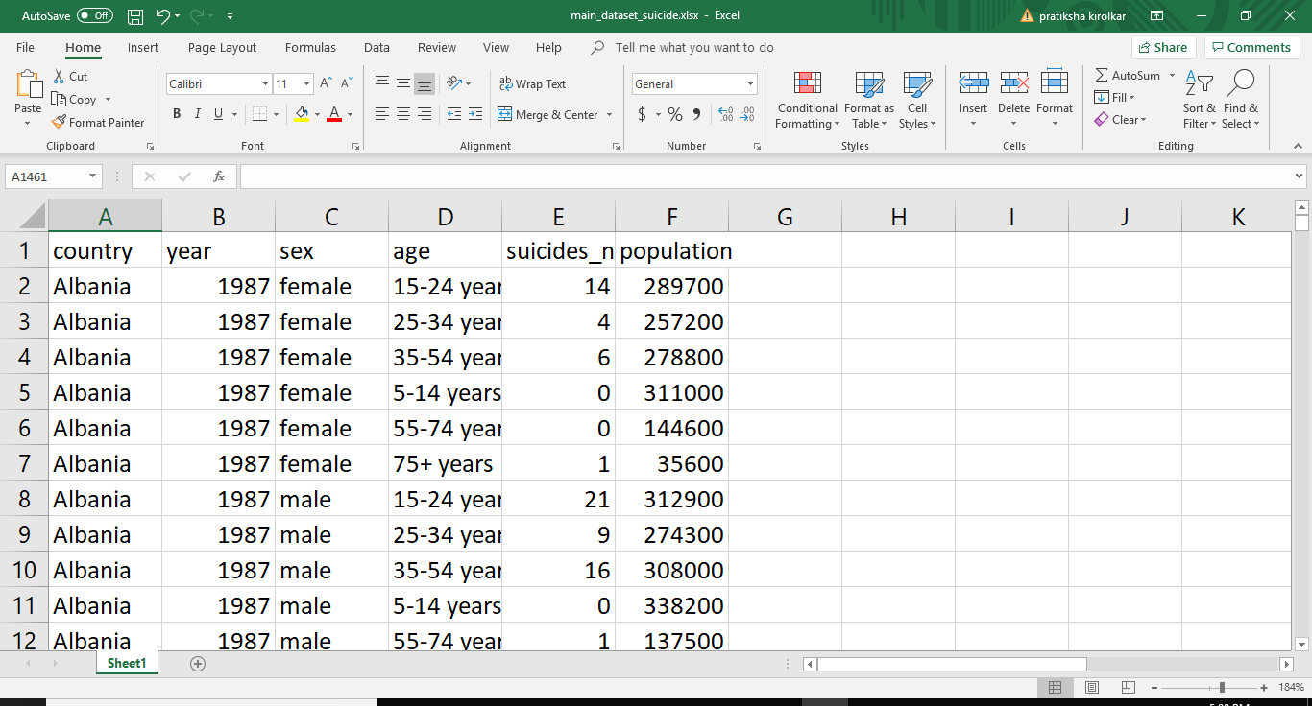

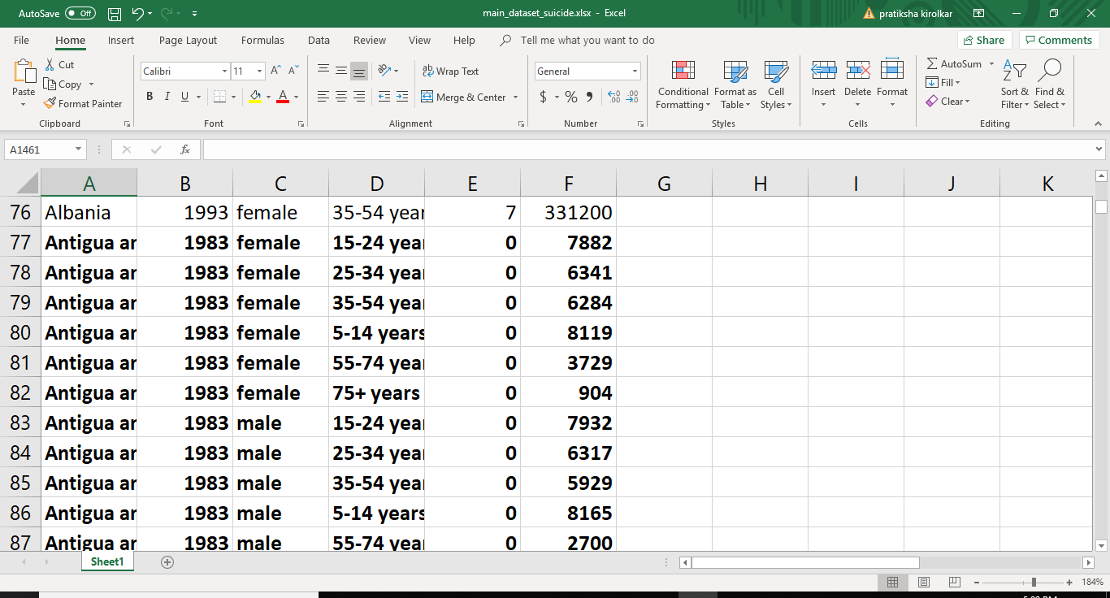

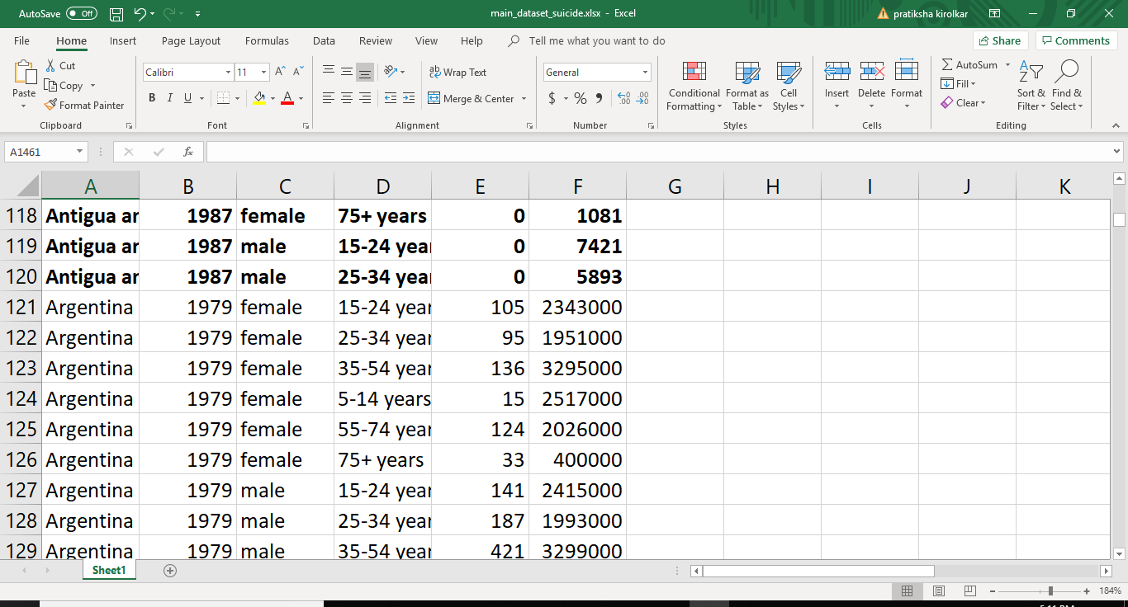

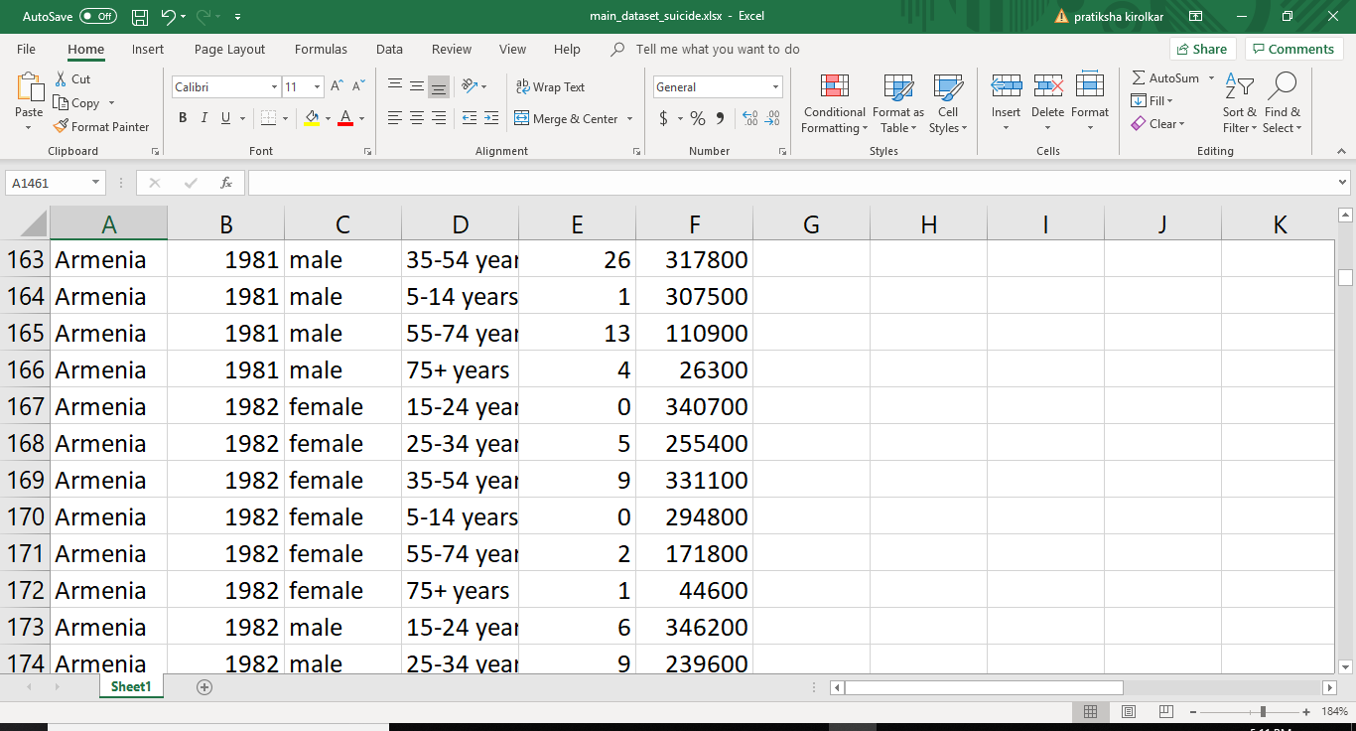

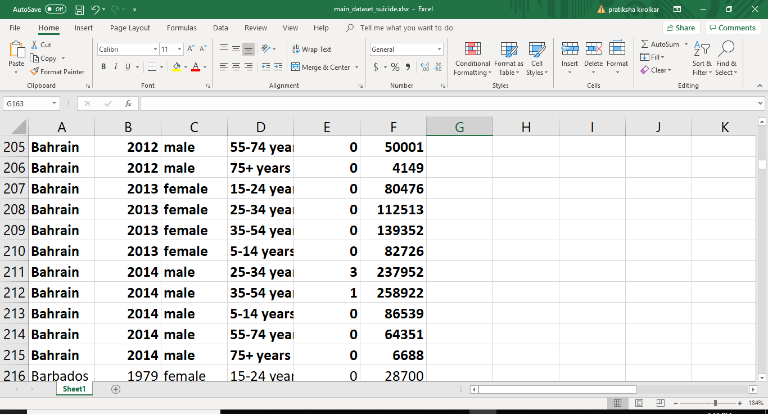

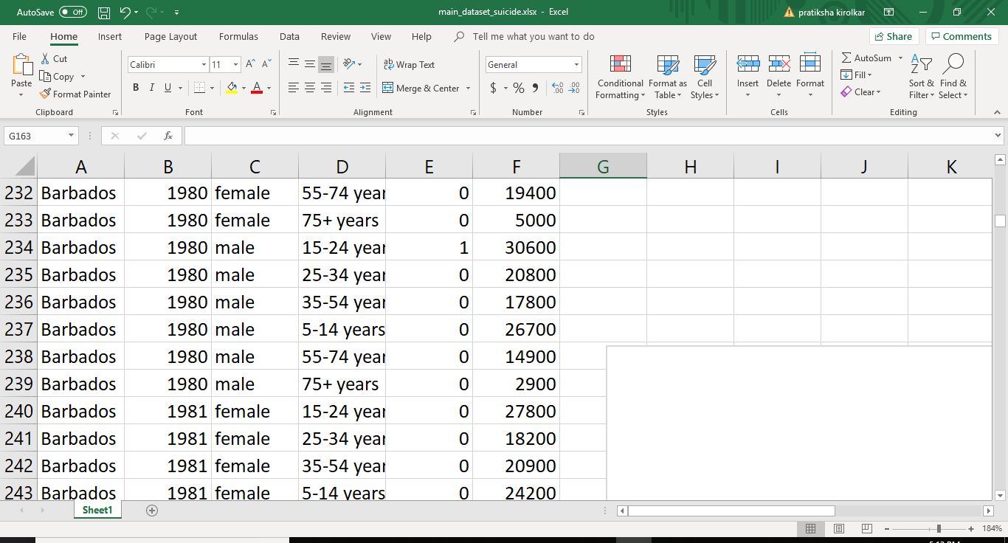

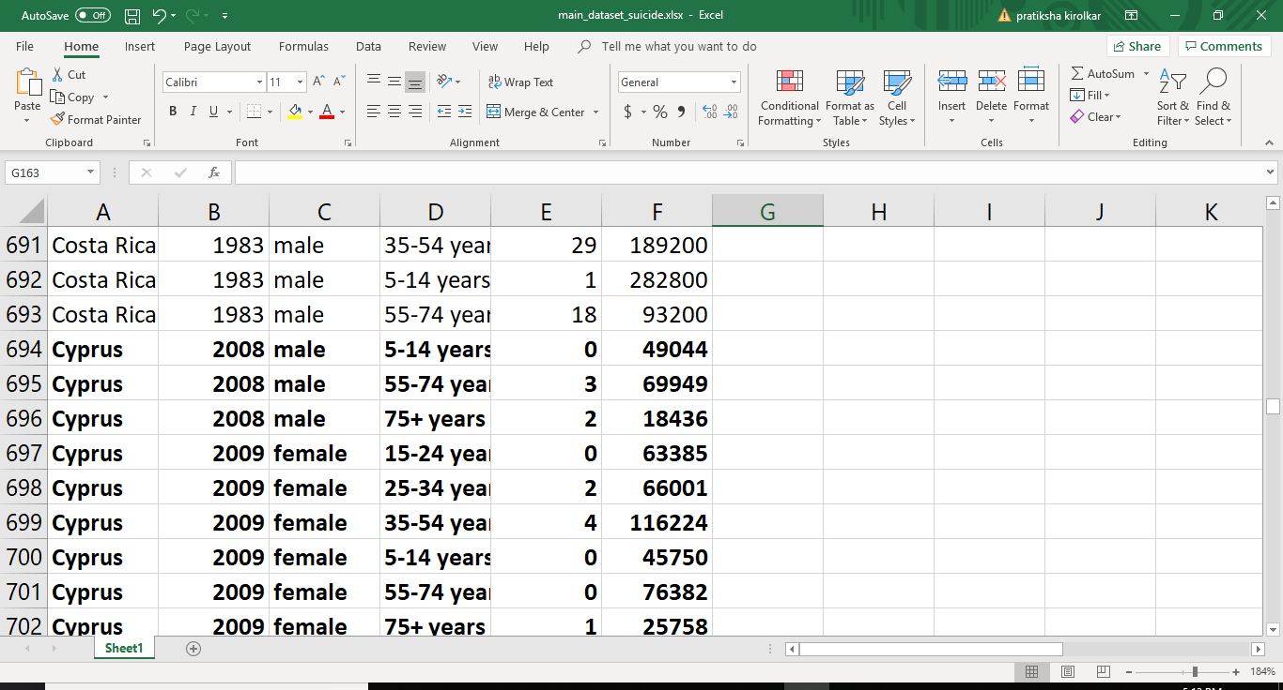

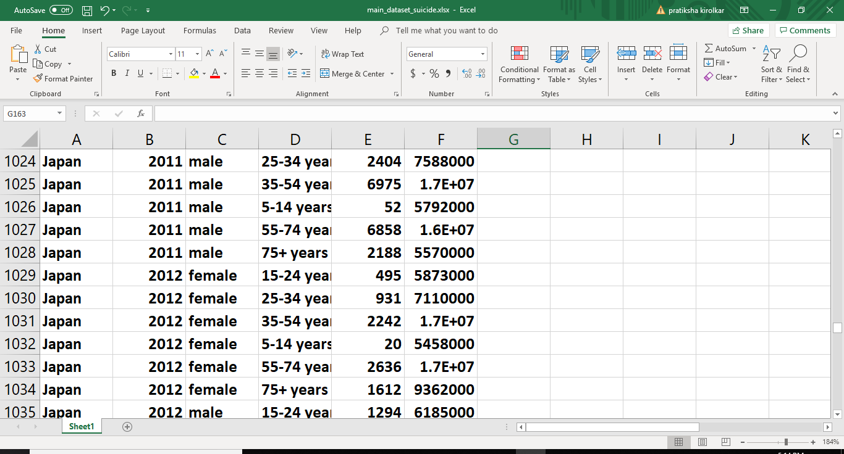

**Advantage**

1. We provide the proper analyze view in Graphical representation manner.
2. We also provide the map view and graphical representation of Suicide location.

**Disadvantage**

1. We not provide the all country suicide information.
2. We not provide the location tracking system in this website.

**System Design Details**

1. **Flowchart**

Home Page (Main Page)

**|**

To select one of the options of nav bar.

**|**

Then cursor goes to the corresponding link pages.

**|**

Then the suicide attempts analyze graphs and check it.

**|**

Then cursor goes to the dropdown menu link pages.

**|**

Graphical representation.

**|**

**Map view** of various countries.

1. **Methodology**:

* Home page
* Selection of navbar items.
* Selection of analyze graph.
* View the graph
* View the map

**3)Flow of website:**

Home page (Main page) ----navbar menu----About us page----list of country ------country information and specific suicide attempts numbers------Analyse graph---Map view of various country--contact us page.

4) **Tableau software connected to cloudera cloud.**

**5) cloudera virtual machine**

* For connection of Tableau and cloudera.
* For import dataset on cloudera.

**6) steps**

Install Hive package

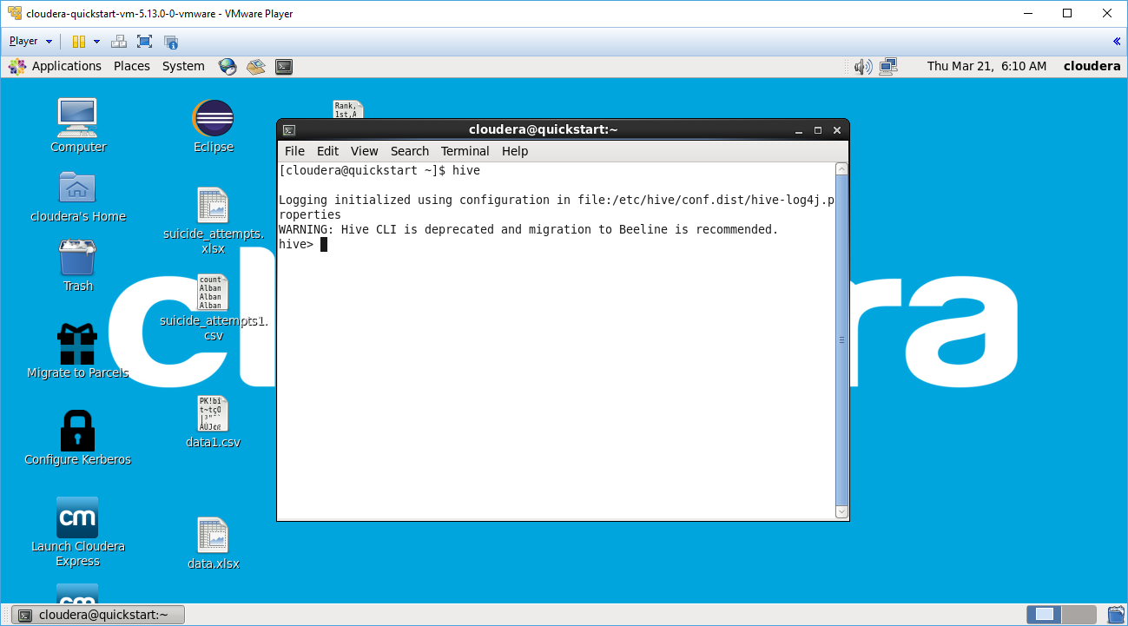

Create database and then use the database.

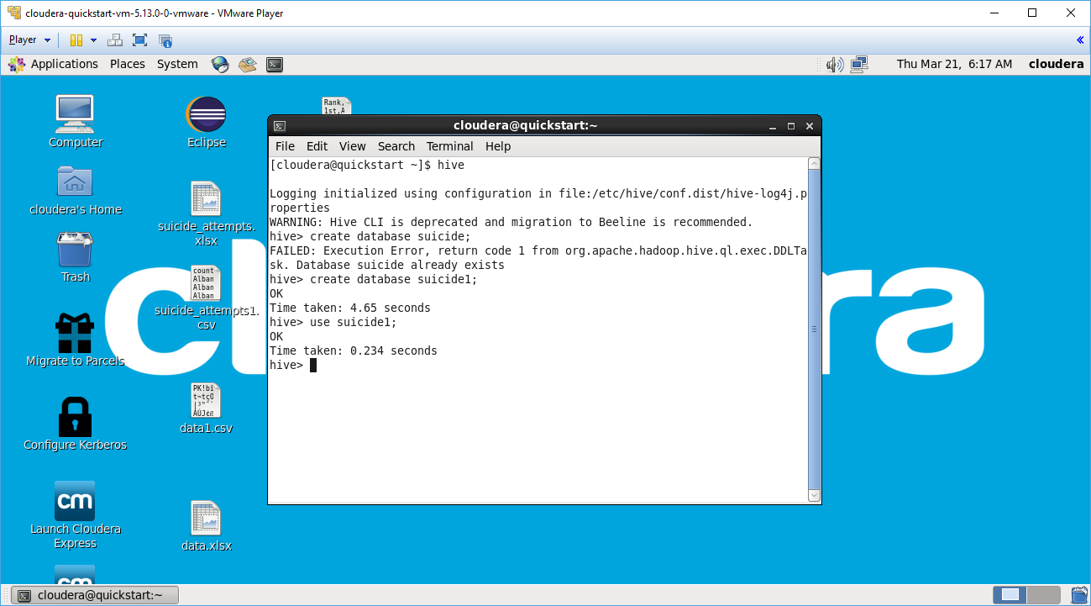

Create table.

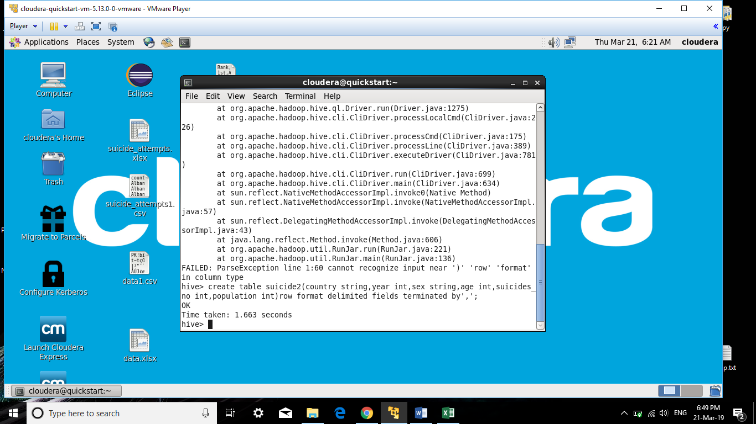

Describe table and load the csv file into database.

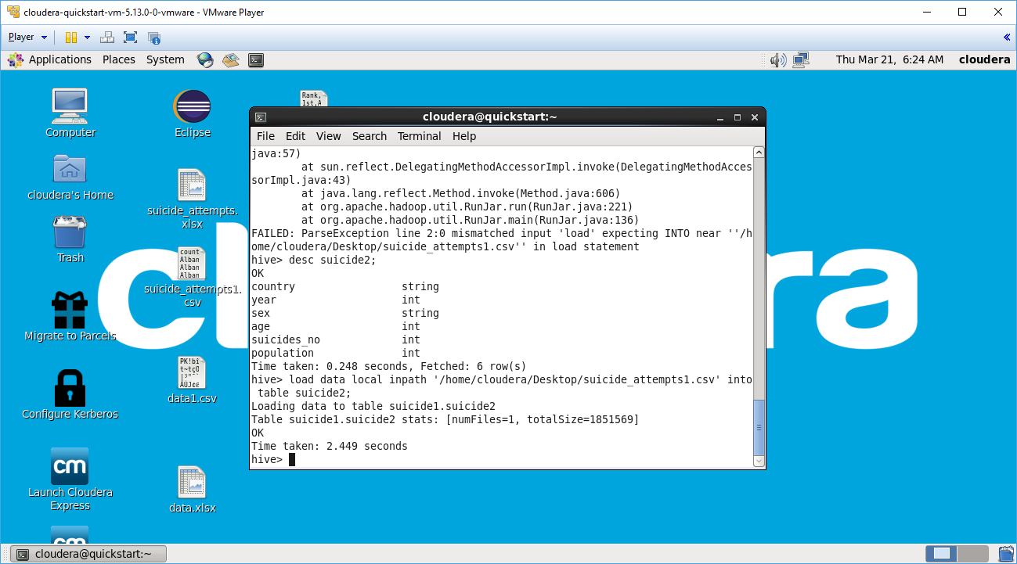

Check ip address of virtual machine.

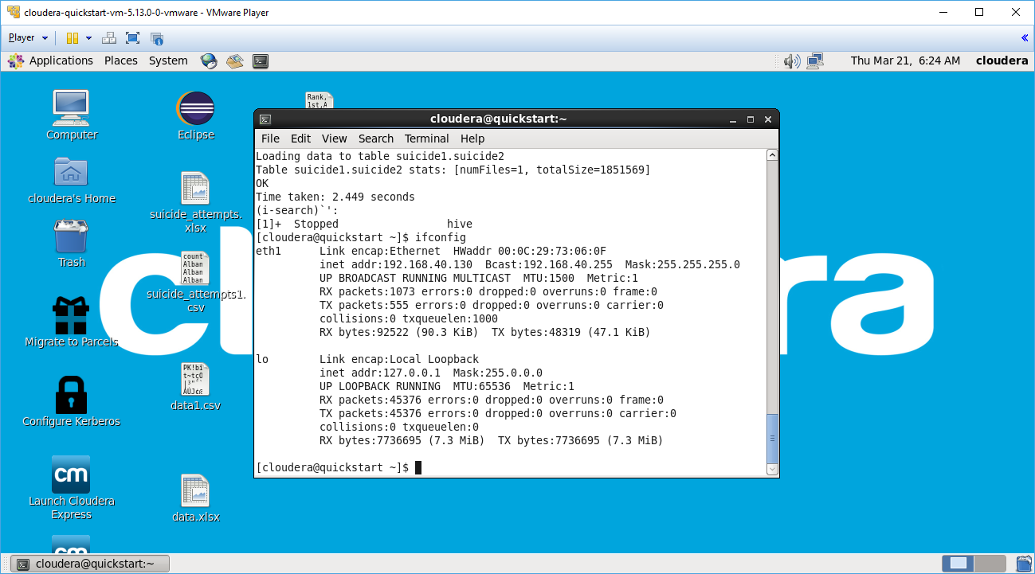

Open tableau and then select cloudera Hadoop.

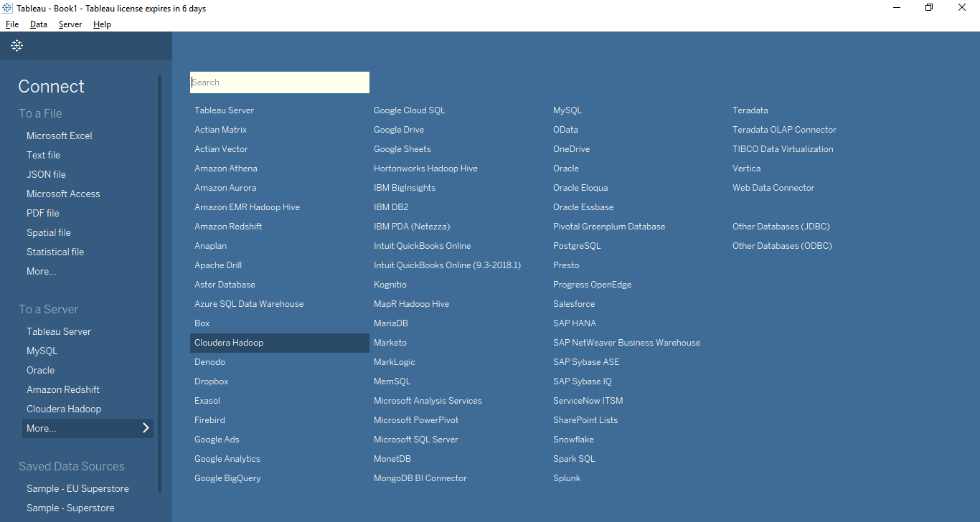

Connectivity between cloudera and tableau.

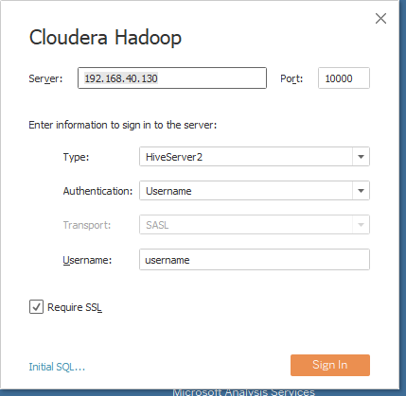

Select database.

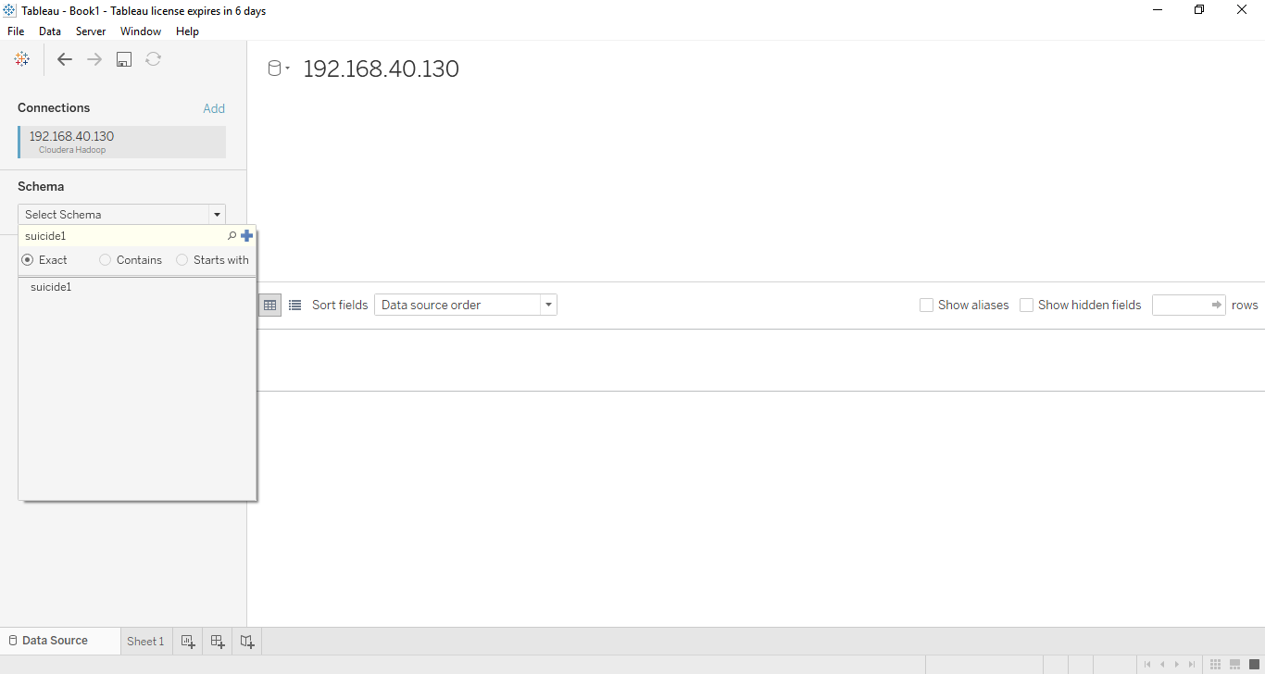

Select table.

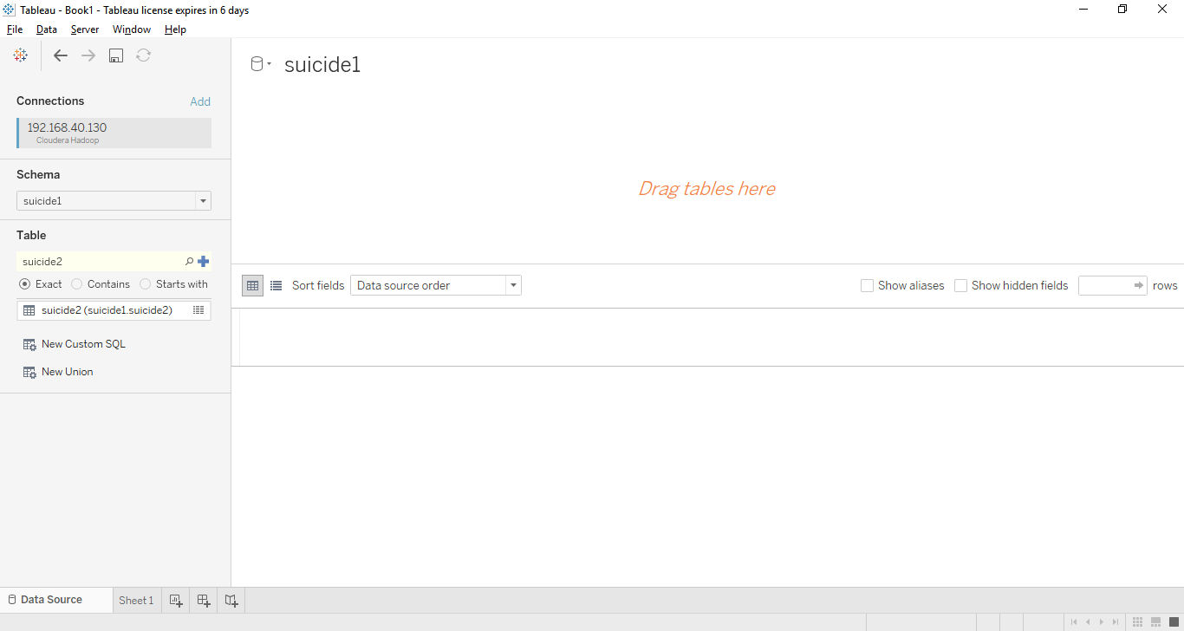

**System Implementation**

1. **Home page:**

**index.html:**

<!DOCTYPE html>

<html><head>

<meta charset="utf-8">

<meta name="viewport" content="width=device-width, initial-scale=1.0">

<title>home_page</title>

<link rel="stylesheet" href="assets/bootstrap/css/bootstrap.min.css">

<link rel="stylesheet" href="https://fonts.googleapis.com/css?family=Cookie">

<link rel="stylesheet" href="assets/css/user.css">

<link rel="stylesheet" href="assets/bootstrap/fonts/font-awesome.min.css">

</head>

<style type="text/css">

body

{

background-color: #D3D3D3;

}

</style><body>

<nav class="navbar navbar-inverse navbar-fixed-top">

<div class="container-fluid">

<div class="navbar-header"><a class="navbar-brand navbar-link menu" href="file:///F:/final_project_sem6/main/index.html">

</i>@Suicide_Feed..! </a> </div>

<div class="collapse navbar-collapse" id="navcol-1">

<ul class="nav navbar-nav navbar-right menu">

<li class="active" role="presentation"><a href="file:///F:/final_project_sem6/main/index.html">HOME </a></li>

<li role="presentation"><a href="file:///F:/final_project_sem6/about%20us/index.html">ABOUT US</a></li>

<li role="presentation"><a href="file:///F:/final_project_sem6/analyze/index.html">ANALYZE VIEW</a></li> <li role="presentation"><a href="file:///F:/final_project_sem6/map/index.html">MAP VIEW</a></li>

<li role="presentation"><a href="file:///F:/final_project_sem6/analyze/index.html">ANALYZE VIEW</a></li> <li role="presentation"><a href="file:///F:/final_project_sem6/contact/index.html">CONTACT US</a></li>

</ul> </div></div> </nav>

<div id="promo">

<div class="jumbotron">

<h1 class="text-center text-muted">Suicide Attempts Feed !</h1>

<p class="text-center"> We show the all statistical suicide attempts....</p>

<p><a class="btn btn-danger" role="button" href="file:///F:/final_project_sem6/learnmore/index.html">Learn more</a>

</p><p class="text-center"></p>

<div class="col-md-12"></div>

</div></div>

<div class="container" id="gb">

<h1>WELCOME TO SUICIDE ATTEMPTS FEED ......!</h1>

<p>We provide the suicide attempts analyze graph and there information.</p>

</div>

<div class="col-md-12"></div>

<div class="hn">

<div class="row">

<div class="col-md-2"></div>

<div class="col-md-8" id="gh">

<div class="carousel slide" data-ride="carousel" id="carousel-1">

<div class="carousel-inner" role="listbox">

<div class="item active"><img src="F:\final_project_sem6\image\pic4.jpg" alt="Slide Image" class="bg"></div>

<div class="item"><img src="F:\final_project_sem6\image\pic2.jpg" alt="Slide Image" id="df" class="bg"></div>

<div class="item"><img src="F:\final_project_sem6\image\pic3.jpg" alt="Slide Image" class="bg"></div>

</div>

<div><a class="left carousel-control" href="#carousel-1" role="button" data-slide="prev"><i class="glyphicon glyphicon-chevron-left"></i><span class="sr-only">Previous</span></a><a class="right carousel-control" href="#carousel-1" role="button"

data-slide="next"><i class="glyphicon glyphicon-chevron-right"></i><span class="sr-only">Next</span></a></div>

<ol class="carousel-indicators">

<li data-target="#carousel-1" data-slide-to="0" class="active"></li>

<li data-target="#carousel-1" data-slide-to="1"></li>

<li data-target="#carousel-1" data-slide-to="2"></li>

</ol></div></div>

<div class="col-md-2"></div>

</div> </div>

<script src="assets/js/jquery.min.js"></script>

<script src="assets/bootstrap/js/bootstrap.min.js"></script>

</body>

<div class="col-md-12">

<footer>

<div class="row">

<div class="col-md-4 col-sm-6 footer-navigation">

<h3><a href="file:///F:/final_project_sem6/main/index.html">@suicide_feed </a></h3>

<p class="links"><a href="file:///F:/final_project_sem6/main/index.html">Home</a><strong> · </strong><a href="file:///F:/final_project_sem6/conutry/index.html">Blog</a><strong> · </strong>

<a href="file:///F:/final_project_sem6/about%20us/index.html">About</a><strong> · </strong>

<a href="file:///F:/final_project_sem6/contact/index.html">Contact</a></p>

<p

class="company-name">Company Name © 2019 </p> </div>

<div class="col-md-4 col-sm-6 footer-contacts">

<div><span class="fa fa-map-marker footer-contacts-icon"> </span>

<p>Nerul, navi mumbai.</p> </div>

<div><span class="fa fa-phone footer-contacts-icon"></span>

<p class="footer-center-info email text-left">+91 8648921573</p>

</div>

<div><span class="fa fa-envelope footer-contacts-icon"></span>

<p> <a href="file:///F:/final_project_sem6/main/index.html" target="_blank">suicide@company.com</a></p>

</div> </div>

<div class="clearfix visible-sm-block"></div>

<div class="col-md-4 footer-about">

<h4>About the company</h4>

<p>We provide the best knowlegeble information of various coutries and there suicide attempts number.</p>

</div></div>

</footer>

</div></div>

<script src="assets/js/jquery.min.js"></script>

<script src="assets/bootstrap/js/bootstrap.min.js"></script>

</html>

1. **About us page:**

**index.html**

<!DOCTYPE html>

<html><head>

<meta charset="utf-8">

<meta name="viewport" content="width=device-width, initial-scale=1.0">

<title>about_us_page</title>

<link rel="stylesheet" href="assets/bootstrap/css/bootstrap.min.css">

<link rel="stylesheet" href="https://fonts.googleapis.com/css?family=Cookie">

<link rel="stylesheet" href="assets/css/user.css">

<link rel="stylesheet" href="assets/bootstrap/fonts/font-awesome.min.css">

</head><style type="text/css">

body

{

background-color: #D3D3D3;

}

</style><body>

<nav class="navbar navbar-inverse navbar-fixed-top">

<div class="container-fluid">

<div class="navbar-header"><a class="navbar-brand navbar-link menu" href="file:///F:/final_project_sem6/main/index.html">

</i>@Suicide_Feed..! </a></div>

<div class="collapse navbar-collapse" id="navcol-1">

<ul class="nav navbar-nav navbar-right menu">

<li class="active" role="presentation"><a href="file:///F:/final_project_sem6/main/index.html">HOME </a></li>

<li role="presentation"><a href="file:///F:/final_project_sem6/about%20us/index.html">ABOUT US</a></li>

<li role="presentation"><a href="file:///F:/final_project_sem6/analyze/index.html">ANALYZE VIEW</a></li>li role="presentation"><a href="file:///F:/final_project_sem6/map/index.html">MAP VIEW</a></li>

<li role="presentation"><a href="file:///F:/final_project_sem6/conclusion/index.html">CONCLUSION</a></li>

<li role="presentation"><a href="file:///F:/final_project_sem6/contact/index.html">CONTACT US</a></li>

</ul></div> </div></nav><div></div><div></div>

<br><br><br><br><br><br><br><center>

<img src="F:\final_project_sem6\image\pic7.png" width="500" height="400"></center>

<div class="promo1">

<div class="box"> <form>

<h1 class="abt">About Us</h1>

<p>We provide the best knowlegeble information of various coutries and there suicide attempts number.

In this project, we must conclude the various country suicide attempts in graphical representation with the help of dataset.

Finally, on the ethics of suicide, it must be noted that suicide is an act, a definite act with very final consequences. Therefore, this act must be looked at differently from some other issues of modern freedoms, or even ideas surrounding the right to die with dignity.

</p></form>

</div></div><footer>

<div class="row">

<div class="col-md-4 col-sm-6 footer-navigation">

<h3><a href="file:///F:/final_project_sem6/main/index.html">@suicide_feed </a></h3>

<p class="links"><a href="file:///F:/final_project_sem6/main/index.html">Home</a><strong> · </strong><a href="file:///F:/final_project_sem6/conutry/index.html">Blog</a><strong> · </strong>

<a href="file:///F:/final_project_sem6/about%20us/index.html">About</a><strong> · </strong>

<a href="file:///F:/final_project_sem6/contact/index.html">Contact</a></p>

<p class="company-name">Company Name © 2019 </p></div>

<div class="col-md-4 col-sm-6 footer-contacts">

<div><span class="fa fa-map-marker footer-contacts-icon"> </span>

<p>Nerul, navi mumbai.</p></div>

<div><span class="fa fa-phone footer-contacts-icon"></span>

<p class="footer-center-info email text-left">+91 8648921573</p>

</div>

<div><span class="fa fa-envelope footer-contacts-icon"></span>

<p> <a href="file:///F:/final_project_sem6/main/index.html" target="_blank">suicide@company.com</a></p>

</div></div>

<div class="clearfix visible-sm-block"></div>

<div class="col-md-4 footer-about">

<h4>About the company</h4>

<p>We provide the best knowlegeble information of various coutries and there suicide attempts number.</p>

</div></div>

</footer>

<script src="assets/js/jquery.min.js"></script>

<script src="assets/bootstrap/js/bootstrap.min.js"></script>

</body></html>

1. **Map View page:**

**index.html**

<!DOCTYPE html>

<html><head>

<meta charset="utf-8">

<meta name="viewport" content="width=device-width, initial-scale=1.0">

<title>map_view</title>

<link rel="stylesheet" href="assets/bootstrap/css/bootstrap.min.css">

<link rel="stylesheet" href="https://fonts.googleapis.com/css?family=Cookie">

<link rel="stylesheet" href="assets/css/user.css">

<link rel="stylesheet" href="assets/bootstrap/fonts/font-awesome.min.css">

</head><style type="text/css">

body

{

background-color: #D3D3D3;

}

h1

{

text-align: center;

}

</style><body>

<nav class="navbar navbar-inverse navbar-fixed-top">

<div class="container-fluid">

<div class="navbar-header"><a class="navbar-brand navbar-link menu" href="file:///F:/final_project_sem6/main/index.html">

</i>@Suicide_Feed..! </a></div>

<div class="collapse navbar-collapse" id="navcol-1">

<ul class="nav navbar-nav navbar-right menu">

<li class="active" role="presentation"><a href="file:///F:/final_project_sem6/main/index.html">HOME </a></li>

<li role="presentation"><a href="file:///F:/final_project_sem6/about%20us/index.html">ABOUT US</a></li>

<li role="presentation"><a href="file:///F:/final_project_sem6/analyze/index.html">ANALYZE VIEW</a></li>li role="presentation"><a href="file:///F:/final_project_sem6/map/index.html">MAP VIEW</a></li>

<li role="presentation"><a href="file:///F:/final_project_sem6/conclusion/index.html">CONCLUSION</a></li>

<li role="presentation"><a href="file:///F:/final_project_sem6/contact/index.html">CONTACT US</a></li>

</ul> </div></div>

</nav><div class="container"></div><div id="promo">

<div class="jumbotron">

<h1 class="text-center text-muted">Suicide Attempts Feed !</h1>

<p class="text-center"> We show the all statistical suicide attempts....</p>

<p class="text-center"></p>

<div class="col-md-12"></div></div></div>

<h1>We provide the suicide attempts analyze graph and there information.</h1>

<div><center>

<iframe src="https://www.google.com/maps/d/u/0/embed?mid=1srBlIUAHNBw1QtxW6blFpxKOM81f-7YK" width="85%" height="600"></iframe></center></div>

<footer><div class="row">

<div class="col-md-4 col-sm-6 footer-navigation">

<h3><a href="file:///F:/final_project_sem6/main/index.html">@suicide_feed </a></h3><p class="links"><a href="file:///F:/final_project_sem6/main/index.html">Home</a><strong> · </strong><a href="file:///F:/final_project_sem6/conutry/index.html">Blog</a><strong> · </strong>

<a href="file:///F:/final_project_sem6/about%20us/index.html">About</a><strong> · </strong>

<a href="file:///F:/final_project_sem6/contact/index.html">Contact</a></p>

<p

class="company-name">Company Name © 2019 </p></div>

<div class="col-md-4 col-sm-6 footer-contacts">

<div><span class="fa fa-map-marker footer-contacts-icon"> </span>

<p>Nerul, navi mumbai.</p></div>

<div><span class="fa fa-phone footer-contacts-icon"></span>

<p class="footer-center-info email text-left">+91 8648921573</p>

</div>

<div><span class="fa fa-envelope footer-contacts-icon"></span>

<p> <a href="file:///F:/final_project_sem6/main/index.html" target="_blank">suicide@company.com</a></p>

</div></div>

<div class="clearfix visible-sm-block"></div>

<div class="col-md-4 footer-about">

<h4>About the company</h4>

<p>We provide the best knowlegeble information of various coutries and there suicide attempts number.</p></div></div></footer>

<script src="assets/js/jquery.min.js"></script>

<script src="assets/bootstrap/js/bootstrap.min.js"></script></body></html>

1. **Contact us page:**

**index.html**

<!DOCTYPE html>

<html><head>

<meta charset="utf-8">

<meta name="viewport" content="width=device-width, initial-scale=1.0">

<title>contact</title>

<link rel="stylesheet" href="assets/bootstrap/css/bootstrap.min.css">

<link rel="stylesheet" href="https://fonts.googleapis.com/css?family=Cookie">

<link rel="stylesheet" href="assets/css/user.css">

<link rel="stylesheet" href="assets/bootstrap/fonts/font-awesome.min.css">

</head><style type="text/css">

body

{

background-color: #D3D3D3;

}

h1

{

text-align: center;

}

.con

{

font-size: 25px;

}

.con1

{

color: blue;

}

</style><body>

<nav class="navbar navbar-inverse navbar-fixed-top">

<div class="container-fluid">

<div class="navbar-header"><a class="navbar-brand navbar-link menu" href="file:///F:/final_project_sem6/main/index.html">

</i>@Suicide_Feed..! </a>

</div><div class="collapse navbar-collapse" id="navcol-1">

<ul class="nav navbar-nav navbar-right menu">

<li class="active" role="presentation"><a href="file:///F:/final_project_sem6/main/index.html">HOME </a></li>

<li role="presentation"><a href="file:///F:/final_project_sem6/about%20us/index.html">ABOUT US</a></li>

<li role="presentation"><a href="file:///F:/final_project_sem6/analyze/index.html">ANALYZE VIEW</a></li> <li role="presentation"><a href="file:///F:/final_project_sem6/map/index.html">MAP VIEW</a></li>

<li role="presentation"><a href="file:///F:/final_project_sem6/conclusion/index.html">CONCLUSION</a></li>

<li role="presentation"><a href="file:///F:/final_project_sem6/contact/index.html">CONTACT US</a></li>

</ul></div></div></nav><div class="container"></div>

<div id="promo"><div class="jumbotron">

<h1 class="text-center text-muted">CONTACT US</h1>

<p class="text-center"> While we are good with providing analyze view and there representation , then there are simpler way for us to get in touch and answer your questions.</p><p class="text-center"></p>

<div class="col-md-12"></div></div></div>

<br><br><h1 class="con1"><b>Contact Information</b></h1>

<br><br><div class="col-md-12"><div class="row">

<div class=" col-md-6 col-sm-6">

<h1>+91 8648921573</h1>

<h1 class="con">Monday - Saturday</h1>

<h1 class="con">10:00 to 05:00</h1>

</div><div class="col-md-4">

<h2><b>About the company</b></h2>

<p>We provide the best knowlegeble information of various coutries and there suicide attempts number.</p></div>

<div class="col-md-4 col-sm-6">

<h2><b>Address</b></h2>

<p>7606, Southhwest road</p>

<p>new place apartment,Near south garden..</p>

<p>Nerul, Navi Mumbai.</p>

</div></div></div><div class="col-md-12">

<footer><div class="row">

<div class="col-md-4 col-sm-6 footer-navigation">

<h3><a href="file:///F:/final_project_sem6/main/index.html">@suicide_feed </a></h3><p class="links"><a href="file:///F:/final_project_sem6/main/index.html">Home</a><strong> · </strong><a href="file:///F:/final_project_sem6/conutry/index.html">Blog</a><strong> · </strong>

<a href="file:///F:/final_project_sem6/about%20us/index.html">About</a><strong> · </strong>

<a href="file:///F:/final_project_sem6/contact/index.html">Contact</a></p><p

class="company-name">Company Name © 2019 </p></div>

<div class="col-md-4 col-sm-6 footer-contacts">

<div><span class="fa fa-map-marker footer-contacts-icon"> </span>

<p>Nerul, navi mumbai.</p></div>

<div><span class="fa fa-phone footer-contacts-icon"></span>

<p class="footer-center-info email text-left">+91 8648921573</p>

</div>

<div><span class="fa fa-envelope footer-contacts-icon"></span>

<p> <a href="file:///F:/final_project_sem6/main/index.html" target="_blank">suicide@company.com</a></p></div></div>

<div class="clearfix visible-sm-block"></div>

<div class="col-md-4 footer-about">

<h4>About the company</h4>

<p>We provide the best knowlegeble information of various coutries and there suicide attempts number.</p>

</div></div></footer></div></div>

<script src="assets/js/jquery.min.js"></script>

<script src="assets/bootstrap/js/bootstrap.min.js"></script>

</body>

</html>

1. **Learn more page**

**index.html**

<!DOCTYPE html>

<html><head>

<meta charset="utf-8">

<meta name="viewport" content="width=device-width, initial-scale=1.0">

<title>learnmore</title>

<link rel="stylesheet" href="assets/bootstrap/css/bootstrap.min.css">

<link rel="stylesheet" href="https://fonts.googleapis.com/css?family=Cookie">

<link rel="stylesheet" href="assets/css/user.css">

<link rel="stylesheet" href="assets/bootstrap/fonts/font-awesome.min.css">

</head>

<style type="text/css">

body

{

background-color: #D3D3D3;

}

.p1

{

color: black;

}

</style>

<body>

<nav class="navbar navbar-inverse navbar-fixed-top">

<div class="container-fluid">

<div class="navbar-header"><a class="navbar-brand navbar-link menu" href="file:///F:/final_project_sem6/main/index.html">

</i>@Suicide_Feed..! </a>

</div>

<div class="collapse navbar-collapse" id="navcol-1">

<ul class="nav navbar-nav navbar-right menu">

<li class="active" role="presentation"><a href="file:///F:/final_project_sem6/main/index.html">HOME </a></li>

<li role="presentation"><a href="file:///F:/final_project_sem6/about%20us/index.html">ABOUT US</a></li>

<li role="presentation"><a href="file:///F:/final_project_sem6/analyze/index.html">ANALYZE VIEW</a></li> <li role="presentation"><a href="file:///F:/final_project_sem6/map/index.html">MAP VIEW</a></li>

<li role="presentation"><a href="file:///F:/final_project_sem6/conclusion/index.html">CONCLUSION</a></li>

<li role="presentation"><a href="file:///F:/final_project_sem6/contact/index.html">CONTACT US</a></li>

</ul></div></div></nav>

<br><br><br><br>

<div class="promo1">

<div class="box">

<form>

<div class="container" id="gb">

<h1>WELCOME TO SUICIDE ATTEMPTS FEED ......!</h1>

<p class="p1">We provide the suicide attempts analyze graph and there information.</p>

</div>

<p>We provide the best knowlegeble information of various coutries and there suicide attempts number.

In this project, we must conclude the various country suicide attempts in graphical representation with the help of dataset.

Finally, on the ethics of suicide, it must be noted that suicide is an act, a definite act with very final consequences. Therefore, this act must be looked at differently from some other issues of modern freedoms, or even ideas surrounding the right to die with dignity.

</p></form>

<div class="hn">

<div class="row">

<div class="col-md-2"></div>

<div class="col-md-8" id="gh">

<div class="carousel slide" data-ride="carousel" id="carousel-1">

<div class="carousel-inner" role="listbox">

<div class="item active"><img src="F:\final_project_sem6\image\pic4.jpg" alt="Slide Image" class="bg"></div>

<div class="item"><img src="F:\final_project_sem6\image\pic2.jpg" alt="Slide Image" id="df" class="bg"></div>

<div class="item"><img src="F:\final_project_sem6\image\pic3.jpg" alt="Slide Image" class="bg"></div>

</div>

<div><a class="left carousel-control" href="#carousel-1" role="button" data-slide="prev"><i class="glyphicon glyphicon-chevron-left"></i><span class="sr-only">Previous</span></a><a class="right carousel-control" href="#carousel-1" role="button"

data-slide="next"><i class="glyphicon glyphicon-chevron-right"></i><span class="sr-only">Next</span></a></div>

<ol class="carousel-indicators">

<li data-target="#carousel-1" data-slide-to="0" class="active"></li>

<li data-target="#carousel-1" data-slide-to="1"></li>

<li data-target="#carousel-1" data-slide-to="2"></li>

</ol></div></div>

<div class="col-md-2"></div></div></div>

<div class="col-md-12">

<footer>

<div class="row">

<div class="col-md-4 col-sm-6 footer-navigation">

<h3><a href="file:///F:/final_project_sem6/main/index.html">@suicide_feed </a></h3>

<p class="links"><a href="file:///F:/final_project_sem6/main/index.html">Home</a><strong> · </strong><a href="file:///F:/final_project_sem6/conutry/index.html">Blog</a><strong> · </strong>

<a href="file:///F:/final_project_sem6/about%20us/index.html">About</a><strong> · </strong>

<a href="file:///F:/final_project_sem6/contact/index.html">Contact</a></p>

<p

class="company-name">Company Name © 2019 </p>

</div>

<div class="col-md-4 col-sm-6 footer-contacts">

<div><span class="fa fa-map-marker footer-contacts-icon"> </span>

<p>Nerul, navi mumbai.</p>

</div>

<div><span class="fa fa-phone footer-contacts-icon"></span>

<p class="footer-center-info email text-left">+91 8648921573</p>

</div>

<div><span class="fa fa-envelope footer-contacts-icon"></span>

<p> <a href="file:///F:/final_project_sem6/main/index.html" target="_blank">suicide@company.com</a></p>

</div>

</div>

<div class="clearfix visible-sm-block"></div>

<div class="col-md-4 footer-about">

<h4>About the company</h4>

<p>We provide the best knowlegeble information of various coutries and there suicide attempts number.</p>

</div></div></footer></div>

<script src="assets/js/jquery.min.js"></script>

<script src="assets/bootstrap/js/bootstrap.min.js"></script>

</body></html>

1. **Analyze view page:**

**index.html**

<!DOCTYPE html>

<html><head>

<meta charset="utf-8">

<meta name="viewport" content="width=device-width, initial-scale=1.0">

<title>analyze view</title>

<link rel="stylesheet" href="assets/bootstrap/css/bootstrap.min.css">

<link rel="stylesheet" href="https://fonts.googleapis.com/css?family=Cookie">

<link rel="stylesheet" href="assets/css/user.css">

<link rel="stylesheet" href="assets/bootstrap/fonts/font-awesome.min.css">

</head><style type="text/css">

body

{

background-color: #D3D3D3;

}

.p1

{

color: black;

}</style><body>

<nav class="navbar navbar-inverse navbar-fixed-top">

<div class="container-fluid">

<div class="navbar-header"><a class="navbar-brand navbar-link menu" href="file:///F:/final_project_sem6/main/index.html">

</i>@Suicide_Feed..! </a>

</div> <div class="collapse navbar-collapse" id="navcol-1">

<ul class="nav navbar-nav navbar-right menu">

<li class="active" role="presentation"><a href="file:///F:/final_project_sem6/main/index.html">HOME </a></li>

<li role="presentation"><a href="file:///F:/final_project_sem6/about%20us/index.html">ABOUT US</a></li>

<li role="presentation"><a href="file:///F:/final_project_sem6/analyze/index.html">ANALYZE VIEW</a></li>

<li role="presentation"><a href="file:///F:/final_project_sem6/map/index.html">MAP VIEW</a></li>

<li role="presentation"><a href="file:///F:/final_project_sem6/conclusion/index.html">CONCLUSION</a></li>

<li role="presentation"><a href="file:///F:/final_project_sem6/contact/index.html">CONTACT US</a></li>

</ul></div></div></nav><br><br><br><br>

<div class="container site-section" id="welcome">

<h1><strong>Introduction To PlayStats.</strong></h1>

<p class="p1">We provide the best knowlegeble information of various coutries and there suicide attempts number.

In this project, we must conclude the various country suicide attempts in graphical representation with the help of dataset.

Finally, on the ethics of suicide, it must be noted that suicide is an act, a definite act with very final consequences. Therefore, this act must be looked at differently from some other issues of modern freedoms, or even ideas surrounding the right to die with dignity. </p>

</div><br><br><div><center>

<h1><strong>Graphical Representation of suicide attempts....</strong></h1></center>

</div><br><div class="container site-section" id="why">

<div class="row"><div class="col-md-12" id="c1">

<div><a class="btn btn-default btn-lg first" data-toggle="collapse" aria-expanded="false" aria-controls="collapse-1" role="button" href="#collapse-1">Country popul VS suicide number</a>

<div class="collapse" id="collapse-1">

<div class="thumbnail"><div class="scrollable"><img src="F:\final_project_sem6\final_output_graph\country_popula&suicide.png"></div>

<div class="caption"><h3>Conclusion</h3>

<p>This is the statistical report based on the country population and suicide numbet attampts.</p>

</div></div></div></div></div><div class="col-md-12" id="c2">

<div><a class="btn btn-default btn-lg" data-toggle="collapse" aria-expanded="false" aria-controls="collapse-2" role="button" href="#collapse-2">Country VS sex</a>

<div class="collapse" id="collapse-2">

<div class="thumbnail"><div class="scrollable"><img src="F:\final_project_sem6\final_output_graph\country_sex.png"></div>

<div class="caption"><h3>Conclusion</h3>

<p>This is the statistical report based on the country and sex number.</p>

</div></div></div></div></div><div class="col-md-12" id="c3">

<div><a class="btn btn-default btn-lg first" data-toggle="collapse" aria-expanded="false" aria-controls="collapse-3" role="button" href="#collapse-3">Population VS country</a>

<div class="collapse" id="collapse-3">

<div class="thumbnail"><div class="scrollable"><img src="F:\final_project_sem6\final_output_graph\population_country.png"></div>

<div class="caption"><h3>Conclusion</h3>

<p>This is the statistical report based on the number of population.</p>

</div></div></div> </div></div><div class="col-md-12" id="c4">

<div><a class="btn btn-default btn-lg" data-toggle="collapse" aria-expanded="false" aria-controls="collapse-4" role="button" href="#collapse-4">Sex VS aGE VS suicide number</a>

<div class="collapse" id="collapse-4">

<div class="thumbnail"> <div class="scrollable"><img src="F:\final_project_sem6\final_output_graph\sex&age_sucideno.png"></div>

<div class="caption"><h3>Conclusion</h3>

<p>This is the statistical report based on the age and suicide attempts numbers.</p>

</div></div></div></div></div><div class="col-md-12" id="c5">

<div><a class="btn btn-default btn-lg first" data-toggle="collapse" aria-expanded="false" aria-controls="collapse-5" role="button" href="#collapse-5">Suicide VS country</a>

<div class="collapse" id="collapse-5">

<div class="thumbnail"><div class="scrollable"><img src="F:\final_project_sem6\final_output_graph\suicide_country.png"></div>

<div class="caption"> <h3>Conclusion</h3>

<p>This is the statistical report based on the suicide attempts vs country.</p>

</div></div></div></div></div><div class="col-md-12" id="c6">

<div><a class="btn btn-default btn-lg" data-toggle="collapse" aria-expanded="false" aria-controls="collapse-6" role="button" href="#collapse-6">Suicide VS year</a>

<div class="collapse" id="collapse-6">

<div class="thumbnail"><div class="scrollable"><img src="F:\final_project_sem6\final_output_graph\suicide_year.png"></div>

<div class="caption"><h3>Conclusion</h3>

<p>This is the statistical report based on the suicide attepmts and year.

</p> </div></div></div></div></div></div></div>

<div class="col-md-12"><footer><div class="row">

<div class="col-md-4 col-sm-6 footer-navigation">

<h3><a href="file:///F:/final_project_sem6/main/index.html">@suicide_feed </a></h3>

<p class="links"><a href="file:///F:/final_project_sem6/main/index.html">Home</a><strong> · </strong><a href="file:///F:/final_project_sem6/conutry/index.html">Blog</a><strong> · </strong>

<a href="file:///F:/final_project_sem6/about%20us/index.html">About</a><strong> · </strong>

<a href="file:///F:/final_project_sem6/contact/index.html">Contact</a></p>

<p

class="company-name">Company Name © 2019 </p>

</div>

<div class="col-md-4 col-sm-6 footer-contacts">

<div><span class="fa fa-map-marker footer-contacts-icon"> </span>

<p>Nerul, navi mumbai.</p>

</div>

<div><span class="fa fa-phone footer-contacts-icon"></span>

<p class="footer-center-info email text-left">+91 8648921573</p>

</div>

<div><span class="fa fa-envelope footer-contacts-icon"></span>

<p> <a href="file:///F:/final_project_sem6/main/index.html" target="_blank">suicide@company.com</a></p>

</div>

</div>

<div class="clearfix visible-sm-block"></div>

<div class="col-md-4 footer-about">

<h4>About the company</h4>

<p>We provide the best knowlegeble information of various coutries and there suicide attempts number.</p>

</div></div></footer></div></div>

<script src="assets/js/jquery.min.js"></script>

<script src="assets/bootstrap/js/bootstrap.min.js"></script>

</body></html>

1. **Conclusion page:**

**index.html**

<!DOCTYPE html>

<html><head>

<meta charset="utf-8">

<meta name="viewport" content="width=device-width, initial-scale=1.0">

<title>conclusion</title>

<link rel="stylesheet" href="assets/bootstrap/css/bootstrap.min.css">

<link rel="stylesheet" href="https://fonts.googleapis.com/css?family=Cookie">

<link rel="stylesheet" href="assets/css/user.css">

<link rel="stylesheet" href="assets/bootstrap/fonts/font-awesome.min.css">

</head><body>

<nav class="navbar navbar-inverse navbar-fixed-top">

<div class="container-fluid">

<div class="navbar-header"><a class="navbar-brand navbar-link menu" href="file:///F:/final_project_sem6/main/index.html">

</i>@Suicide_Feed..! </a></div>

<div class="collapse navbar-collapse" id="navcol-1">

<ul class="nav navbar-nav navbar-right menu">

<li class="active" role="presentation"><a href="file:///F:/final_project_sem6/main/index.html">HOME </a></li>

<li role="presentation"><a href="file:///F:/final_project_sem6/about%20us/index.html">ABOUT US</a></li>

<li role="presentation"><a href="file:///F:/final_project_sem6/analyze/index.html">ANALYZE VIEW</a></li>

<li role="presentation"><a href="file:///F:/final_project_sem6/map/index.html">MAP VIEW</a></li>

<li role="presentation"><a href="file:///F:/final_project_sem6/conclusion/index.html">CONCLUSION</a></li>

<li role="presentation"><a href="file:///F:/final_project_sem6/contact/index.html">CONTACT US</a></li>

</ul></div></div></nav> <br><br><br><br>

<div><center>

<h1><strong>Conclusin of the Graphical Representation of suicide attempts....</strong></h1></center></div>

<div class="promo1"><div class="box"> <form>

<p>In this page we conclude the total number of suicide attempts occur in various country based on there population and year based.

we also,conclude the total number of female and total number of male category suicide attempts in year 1985 to 2016.

</p></form></div></div>

<div class="container site-section" id="why"><div class="row">

<div class="col-md-12" id="c1">

<div><a class="btn btn-default btn-lg first" data-toggle="collapse" aria-expanded="false" aria-controls="collapse-1" role="button" href="#collapse-1">full result</a>

<div class="collapse" id="collapse-1">

<div class="thumbnail"><div class="scrollable"><img src="F:\final_project_sem6\full_result.png"></div>

</div></div></div></div><div class="col-md-12" id="c2">

<div><a class="btn btn-default btn-lg" data-toggle="collapse" aria-expanded="false" aria-controls="collapse-2" role="button" href="#collapse-2">country</a>

<div class="collapse" id="collapse-2"><div class="thumbnail">

<div class="scrollable"><img src="F:\final_project_sem6\country.png"></div>

</div></div></div></div></div></div>

<div class="col-md-12"><footer><div class="row">

<div class="col-md-4 col-sm-6 footer-navigation">

<h3><a href="file:///F:/final_project_sem6/main/index.html">@suicide_feed </a></h3>

<p class="links"><a href="file:///F:/final_project_sem6/main/index.html">Home</a><strong> · </strong><a href="file:///F:/final_project_sem6/conutry/index.html">Blog</a><strong> · </strong><a href="file:///F:/final_project_sem6/about%20us/index.html">About</a><strong> · </strong><a href="file:///F:/final_project_sem6/contact/index.html">Contact</a></p>

<p class="company-name">Company Name © 2019 </p></div>

<div class="col-md-4 col-sm-6 footer-contacts">

<div><span class="fa fa-map-marker footer-contacts-icon"> </span>

<p>Nerul, navi mumbai.</p> </div>

<div><span class="fa fa-phone footer-contacts-icon"></span>

<p class="footer-center-info email text-left">+91 8648921573</p>

</div>

<div><span class="fa fa-envelope footer-contacts-icon"></span>

<p> <a href="file:///F:/final_project_sem6/main/index.html" target="_blank">suicide@company.com</a></p></div></div>

<div class="clearfix visible-sm-block"></div>

<div class="col-md-4 footer-about">

<h4>About the company</h4>

<p>We provide the best knowlegeble information of various coutries and there suicide attempts number.</p>

</div></div></footer></div></div>

<script src="assets/js/jquery.min.js"></script>

<script src="assets/bootstrap/js/bootstrap.min.js"></script>

</body></html>

**Results**

**Test case**

1. **TEST CASE 01**

**This test case is suicide attempts number vs. country population. In that test case we show that the total number of suicide attempts and various country populations.**

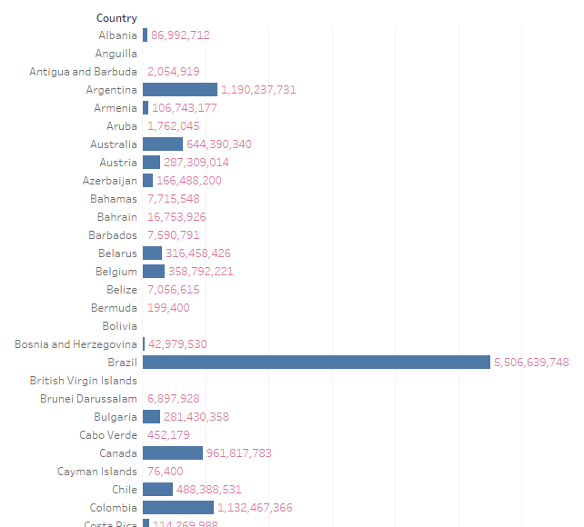

**TEST CASE 02**

**This test case is suicide attempts number vs. year. In that test case show the total number of suicide attempts in specific year.**

**Show the ratio of various suicide attempts numbers.**

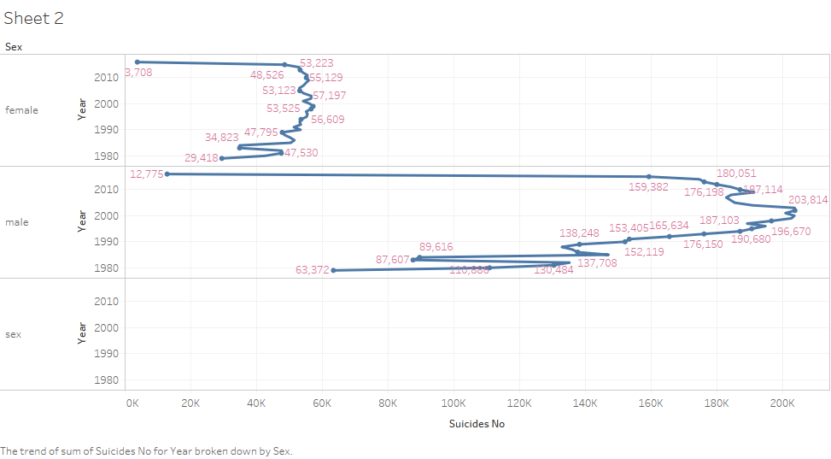

**TEST CASE 03**

**This test case is suicide attempts number vs. age. The graph view is representing the total number of suicide attempts and age.**

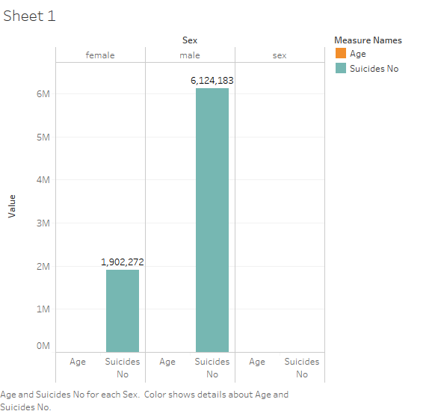

**Conclusion**

In this project, we must conclude the various country suicide attempts in graphical representation with the help of dataset.

Finally, on the ethics of suicide, it must be noted that suicide is an act, a definite act with very final consequences. Therefore, this act must be looked at differently from some other issues of modern freedoms, or even ideas surrounding the right to die with dignity. Proper, timely death can be an affirmation of the life process. These are the distinctions that the nurturers, and all human beings, must make. If life cannot be easily right or wrong, black or white, it can be a process of thoughtful choices that emphasize the compassionate dignity which humans are capable of.

Hopefully, then, the reader will have learned from Plath's art and her life, and thus, *her*tragedy can be another people's salvation.

**Future Enhancement**

In this project, to specify the various country suicide attempts view and with the help of tableau represents the graphical representation of suicide feed.

The future enhancement of given website is following:

* We provide the area-based analyses and show the graphical representation on it.
* We provide the reason for suicide attempts people.
* We provide proper graphical representation on area-based and country-based suicide feed.
* We developed application for suicide attempts feed.

The future enhancement of given project to analyse and collect more information about the various Area and number of suicide attempts in suicide feed dataset.

**References**

* <https://www.kaggle.com/datasets>
* <https://www.kaggle.com/russellyates88/suicide-rates-overview-1985-to-2016>
* <https://www.data.gov/>
* <https://ourworldindata.org/suicide>
* <https://www.who.int/mental_health/prevention/suicide/suicideprevent/en/>
* <https://www.sprc.org/strategic-planning/data>
* <https://www.kaggle.com/antonaks/suicide-attempt-prediction-foreveralone-dataset>
* <https://data.world/datasets/suicide>
* <https://www.google.com/search?q=suicide+attempts+dataset&rlz=1C1CHBF_enIN742IN742&oq=suicide+attempts+dataset&aqs=chrome..69i57.7941j0j4&sourceid=chrome&ie=UTF-8>

Thank You